Assignment #4 – Responsive Web Design (Media Queries + Bootstrap Grid)
Objective
The goal of this assignment was to learn how to create responsive web pages using CSS media queries and the Bootstrap Grid system. The main task was to build a website that adjusts its layout and typography across different screen sizes (mobile, tablet, desktop).
Part 1. Media Queries
Task 0. Responsive Typography
I created a simple web page with headings and paragraphs and applied media queries to automatically adjust font sizes:
- Small on mobile
- Medium on tablet
- Large on desktop
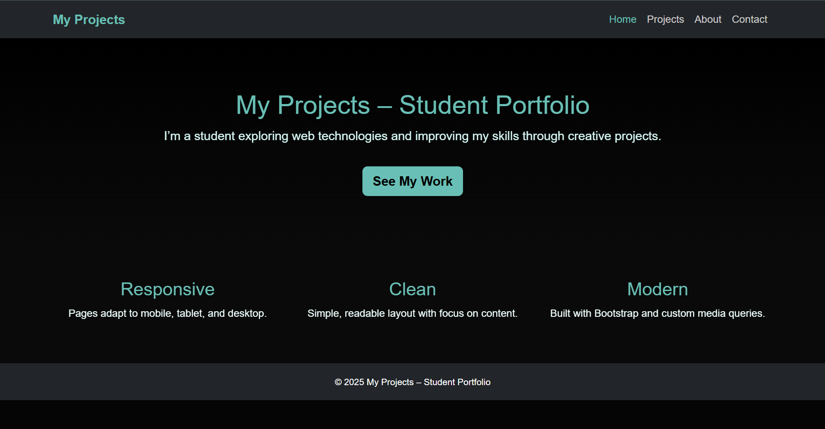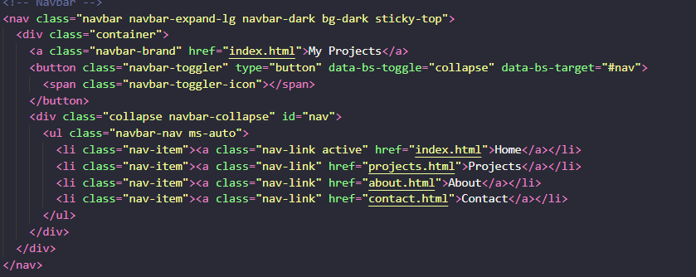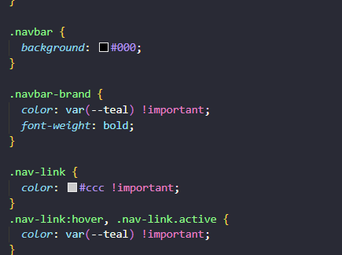

Part 2. Bootstrap Grid System
Task 2. Responsive Columns
I built a responsive 3-column layout using Bootstrap’s 12-column grid:
- Desktop – each column takes 4 columns
- Tablet – two in the first row, one below
- Mobile – all stacked vertically
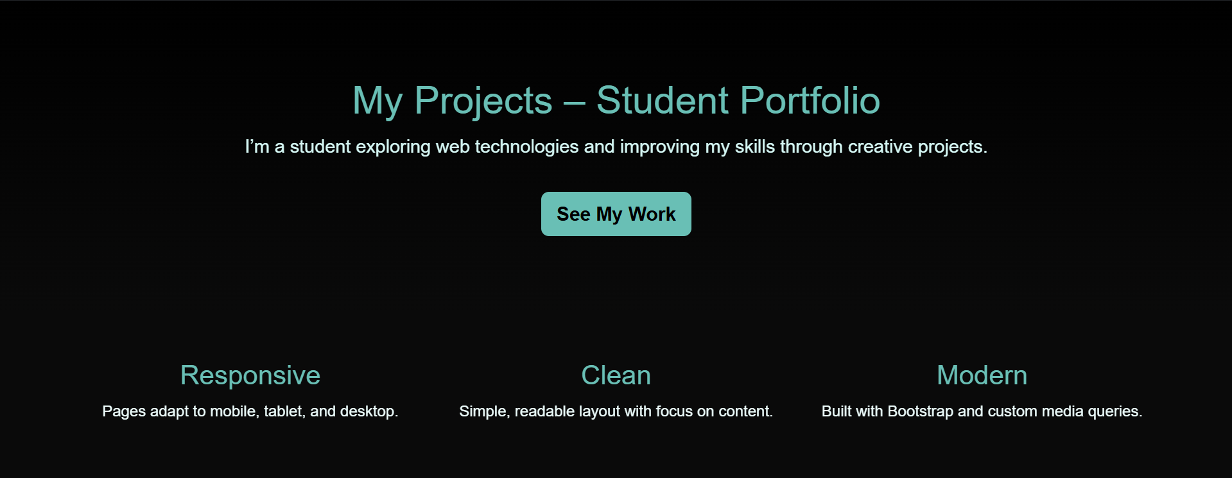
Task 3. Bootstrap Navigation Bar
I created a responsive navigation bar with a logo and links that collapses into a hamburger menu on smaller screens.

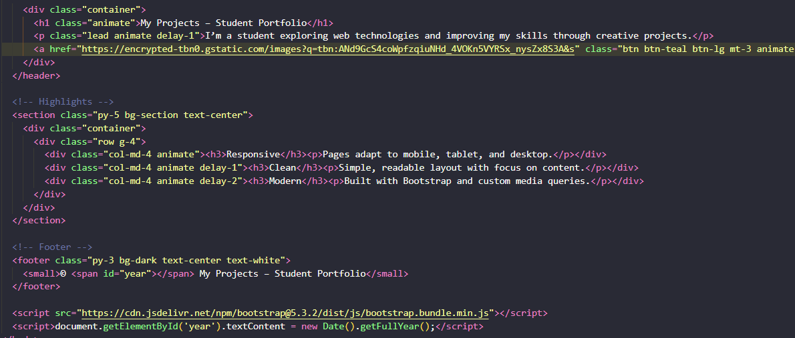
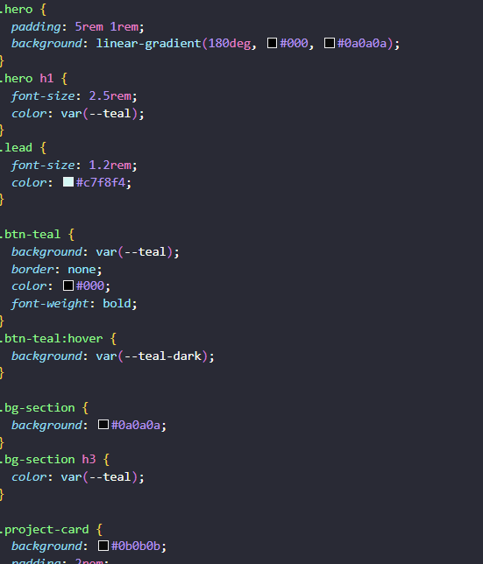
Part 3. Final Project – Portfolio Website
Task 4. Responsive Portfolio Page
I built a complete responsive portfolio website "My Projects – Student Portfolio" with four pages:
- Home – landing page
- Projects – contains Simulation of Life and CleanGov
- About – about me
- Contact – contact information
Main features:
- Media Queries for typography and spacing
- Bootstrap Grid for layout
- Responsive Navbar
- Smooth animations
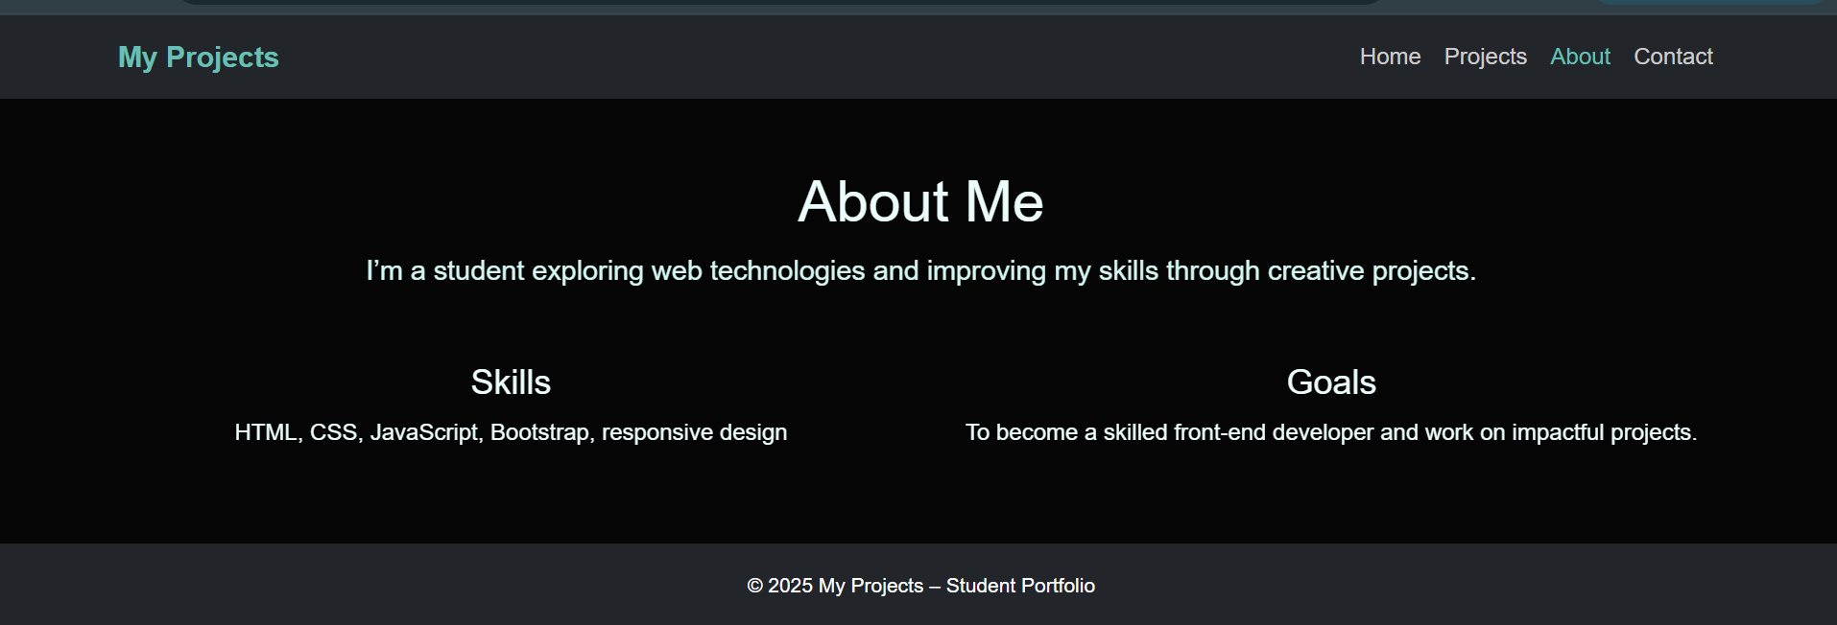
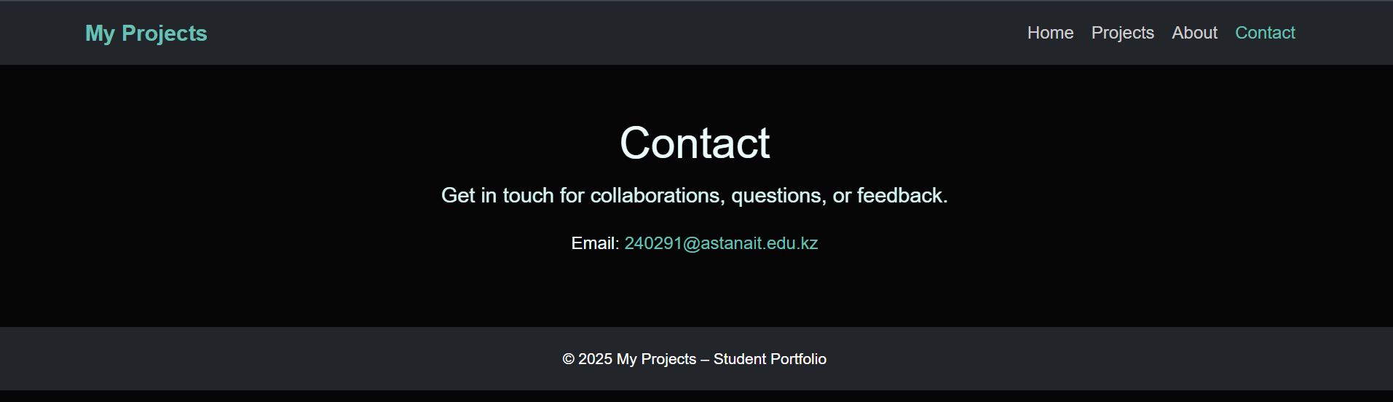
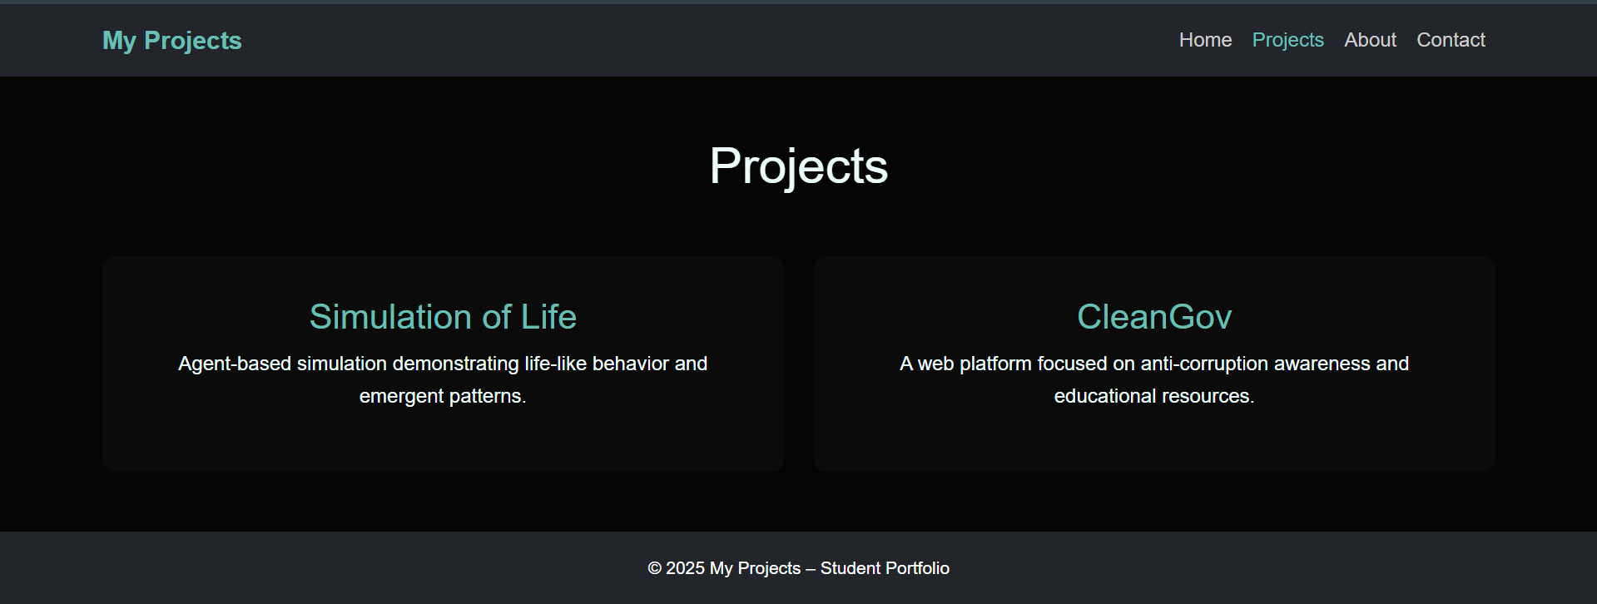
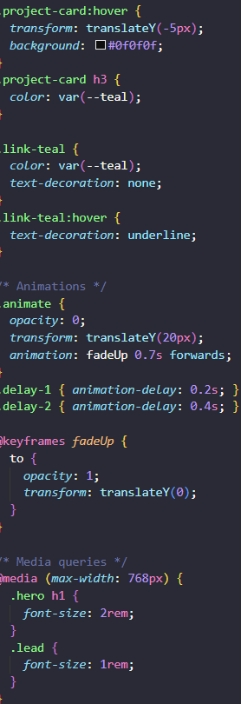
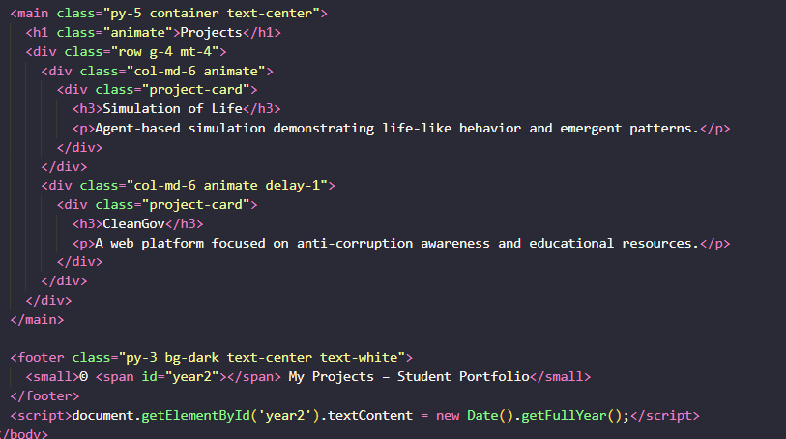
Summary
During this assignment, I created a fully responsive portfolio website "My Projects – Student Portfolio", which includes four pages: Home, Projects, About, and Contact.
Throughout the project, I:
- Learned how to use CSS media queries to adjust typography, spacing, and layout for different screen sizes.
- Gained experience using Bootstrap Grid to build flexible, responsive layouts.
- Implemented a responsive navigation bar that works seamlessly across devices.
- Designed a clean, modern user interface with light animations.
The website meets all assignment requirements and displays correctly on mobile, tablet, and desktop devices.
The project source code is available on GitHub:
https://github.com/XelVarful/Frontend.git

